DETECTION OF THYROID DISORDERS USING MACHINE LEARNING APPOARCH

]

ABSTRACT:
Classification based Machine learning plays a major role in various medical services. In medical field, the salient and demanding task is to diagnose patient’s health conditions and to provide proper care and treatment of the disease at the initial stage. Let us consider Thyroid disease as the example. The normal and traditional methods of thyroid diagnosis involve a thorough inspection and also various blood tests. The main goal is to recognize the disease at the early stages with a very high correctness. Machine learning techniques play a major role in medical field for making a correct decision, proper disease diagnosis and also saves cost and time of the patient. The purpose of this study is prediction of thyroid disease using classification Predictive Modelling followed by binary classification using Decision Tree ID3 and Naive Bayes Algorithms. The Thyroid Patient dataset with proper attributes are fetched and using the Decision Tree algorithm the presence of thyroid in the patient is tested. Further, if thyroid is present then Naïve Bayes algorithm is applied to check for the thyroid stage in the patient.

INDEX
S.NO | CONENTS NAME | PAGE.NO
1 | INTRODUCTION
2 | LITERATURE REVIEW
3 | FEASIBILITY STUDY
4 | SYSTEM REQURIMENT SPECIFICATION
5 | DESIGN & ANALYSIS
6 | IMPLEMENTATION
7 | OUTPUT SCREENS
8 | TESTING AND VALIDATION
9 | CONCLUSION
 | BIBLIOGRAPHY

CHAPTER-1

INTRODUCTION
Motivation
Thyroid disease diagnosis is not a simple task. It involves many procedures. The normal traditional way includes a proper medical examination and many blood samples for blood tests. Therefore, there is a necessity for a model which detects the thyroid disease at a very early stage of development .
In medical field machine learning plays an important role for thyroid disease diagnosis as it has various classification models based on which we can train our model with proper train dataset of the thyroid patient and can predict and give the results in an accurate manner with higher degree of correctness.
Some recent studies from Mumbai have suggested that congenital hypothyroidism is common in India. The disease occurs in 1 part of 2640 new born children, when compared to the worldwide average range of 1 in 3800 considered. Congenital hypothyroidism can lead to serious complications if not detected in early stages. Therefore, the proposed model serves the goal in early detection of thyroid disease.
Based on the obtained test values the health care staff can easily examine the condition of the patient and also skip further clinical examinations if not necessary. Hence, this approach proves to be very much beneficial to the healthcare field. A proper train dataset results into an accurate predicting model therefore reducing the overall cost of the thyroid patient treatment and also saving the time [2]. Classification algorithms are most suitable in decision making and also solving the real world problems.
ABOUT THYROID
The Thyroid is butterfly-shaped endocrine gland which is situated at the base of the human neck. The vital role of the thyroid gland is maintaining and balancing human metabolism and also the growth and development of the human body. The vital tasks performed by thyroid gland are blood circulation, body temperature control, muscle strength and brain functioning [1]. Any damage or improper functioning of the gland may seriously affect the normal human body functioning [2].Therefore, proper thyroid hormone secretion results into a healthy human body. If there is either low or high secretions of the hormone it will adversely affect the human health.
Various Thyroid Harmones and their effects.
The Thyroid gland mainly produces tri-iodothyronine (T3), thyroxine (T4) and Thyroid stimulating hormone (TSH). The Thyroid stimulating hormone (TSH) [3] is released by the pituitary gland which mainly stimulates the thyroid gland to produce T3 and T4 which further stimulate the metabolism of almost every tissue present in the human body. Therefore, the pituitary gland plays a vital role in controlling the production of the required amount of thyroid hormones. If the TSH production level is less then T3, T4 secretion will be more and vice versa.
The Thyroid disorder is the most common endocrine disease across the world. In a survey carried out in India, around 42 million people are suffering from this disease [1]. Thyroid disease is different from other type of endocrine diseases in terms of the mode of treatment relative attainability and the ease of predicting the disease
The high thyroid hormone secretion leads to Hyperthyroidism and low secretion leads to Hypothyroidism. Both the conditions adversely affect the human physiology and the symptoms shown for hyperthyroidism are dry skin, hair thinning, loss of weight, high blood pressure, neck enlargement and short menstrual periods.
The symptoms show for hypothyroidism include the thyroid gland inflammation, weight gain, low blood pressure, heavy menstrual periods and loss of appetite.
These symptoms may get even worse if they are not treated in an early stage. Hence, there is a need for a proper prediction model which helps in diagnosing the patient’s condition in an early stage of the disease

CHAPTER-2

LITERATURSURVEY

2.1 INTRODUCTION
Bibi Amina Begum et al. [1] have proposed different Thyroid prediction techniques using data mining approaches. They have considered different dataset attributes for prediction and have explained the classification techniques in data mining like Decision Tree, Backpropagation Neural Network, SVM and density based clustering. They have analyzed the correlation of T3, T4 and TSH with hyperthyroidism and hypothyroidism.
Ankita Tyagi et al. [2] have studied various classification based machine learning algorithms. They have considered train data set from UCI Machine Learning repository and compared and analyzed the performance metric of decision tree, support vector machine and K-nearest neighbor.
Aswathi A K et al. [3] have proposed a training model consisting of 21 thyroid causing attributes. They have proposed partial swarm optimization to optimize the support vector machine parameters.
M. Deepika et al. [4] have performed a general empirical study on various disease diagnosis like Diabetes, Breast Cancer, Heart disease, Thyroid prediction and have compared the accuracy rate by applying SVM, Decision tree and Artificial Neural Networks.
Sumathi A et al. [5] have considered Thyroid data preprocessing mainly by applying the decision tree algorithm. They have first calculated the mean values of T3, T4 and TSH and considered as the preprocessing stage. Later on they have applied machine learning based feature selection and feature construction. Further they have applied classification based J48 algorithm which is a continuation of ID3 algorithm and calculated the results.
I Md. Dendi Maysanjaya et al. [6] have analyzed a comparison on various classification methods used to diagnose thyroid disease. They have compared by using Artificial Neural Networks, Radial Based Function, Learning Vector Quantization, Back Propagation Algorithm and Artificial Immune recognition system and concluded the comparison results. Among that they found out that Multilayer Perceptron has the highest accuracy of 96.74%
Ammulu K et al. [7] have proposed a Thyroid Prediction System based on data mining classification algorithm. They have used random forest approach to predict the results using Weka open source tool used for data mining. Using this tool they have applied random forest algorithm with 25 thyroid data attributes and predicted the results accordingly.
Roshan Banu D et al. [8] have conducted a study on different data mining techniques to detect thyroid disease. They have done study on Linear Discriminant analysis, Kfold cross validation, and Decision tree. They have analyzed various splitting rules for the attributes of Decision tree. They have also compared the obtained values.
Dr.B.Srinivasan et al. [9] have conducted a study on diagnosis of the thyroid disease using different data mining approaches. They have explained the major cause of the thyroid disease and have also given description about Decision Tree, Naïve Bayes classification and SVM.
Sunila Godara et al. [10] have performed a Prediction on Thyroid Disease using various machine learning techniques. They have considered Logistic Regression and Support Vector Machine as the main Thyroid detection models. They have concluded that these two proposed classifier methods are the best when the number of classes increases in the thyroid prediction model

2.2 EXSISTING SYSTEM
In the data collection stage, small, memory-constrained and low energy-consumption sensors with a short-range communications capability are employed to collect information about the physical environment. Ethernet, WiFi, ZigBee, and wire-based technologies are combined with Transmission Control Protocol/Internet Protocol to connect the objects and users across prolonged distances during data transmission. During the data processing and utilization stage, applications process the data to obtain useful information, and may initiate control commands to act on the physical environment after making decisions based on the collected information. The coordination of diverse technologies, the heterogeneity, and the distributed nature of communications technologies proposed for the IoT by different standards development organizations [4] magnify the threat to end-to-end security in IoT applications

2.3 PROPOSED SYSTEM
The thyroid dataset is taken from Kaggle Machine Learning website [13]. The Database mainly includes the thyroid patient records having all the necessary patient details in it. The patient record has important attributes as mentioned in the Table I. Along with this, the proposed model also takes all the records of the patient’s past clinical history showing in the Fig 1. These include whether the patient is allergic to any particular medicine, whether the patient has undergone any past thyroid surgery and also any recent thyroid test and genetic history of the patient. These also act as the major attributes since they ease the examination of the thyroid patient and reduce the thorough examination by the doctor. This saves time and eases the diagnosis process.
These attributes are stored in a dedicated cloud server which can be made private or hybrid based on the health organization’s need and interest. Among the considered attributes a train dataset is prepared and is given as the input to the classification based machine learning model. This is a supervised learning method and the designed model will generate the results based on the train dataset values. The proposed model has Decision tree and Naive Bayes algorithm to generate the results. A decision tree is a tree based algorithm which follows a top down approach build. ID3 algorithm is used to construct the decision tree. It mainly eliminates any redundant element if present and improves the accuracy of the classification.
This decision tree algorithm is applied to the thyroid patient’s records consisting of age, gender, T3, T4, TSH values. The decision tree algorithm calculates the inputted values present in the thyroid patient record. The calculation is done based on the train dataset. Therefore more the number of records in the train dataset higher the accuracy of the algorithm. For example, if 3000 train thyroid dataset records are considered and trained to the decision tree algorithm then the generated accuracy rate will be high. Our proposed model has considered more than 3000 train dataset attributes resulting in 95% accuracy rate in the prediction results. The algorithm generates yes or no values i.e., whether the thyroid disease is present in the patient or not. If the patient’s output value results true then further Naïve Bayes algorithm is applied to calculate which stage is the patient currently in. This adds as a major advantage to the health care staff in the easy analysis of the thyroid disease and also avoid certain lab tests if not necessary. The patient’s thyroid stage here is divided into 3 stages i.e., minor, major and critical. The Naïve Bayes algorithm is applied if the Decision Tree returns thyroid true or positive value. The Naïve Bayes algorithm in machine learning is a supervised learning algorithm which is based on Bayes’ Theorem.
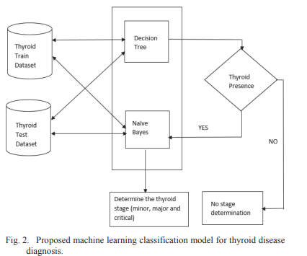

CHAPTER-3
FEASIBILITY STUDY
The feasibility of the project is analyzed in this phase and business proposal is put forth with a very general plan for the project and some cost estimates. During system analysis the feasibility study of the proposed system is to be carried out. This is to ensure that the proposed system is not a burden to the company. For feasibility analysis, some understanding of the major requirements for the system is essential.
Three key considerations involved in the feasibility analysis are
- ECONOMICAL FEASIBILITY
- TECHNICAL FEASIBILITY
- SOCIAL FEASIBILITY

3.1 ECONOMICAL FEASIBILITY
Economical feasibility evaluates the cost-effectiveness of implementing a machine learning model for detecting thyroid disorders. Traditional methods like blood tests, hormone assessments, and physician consultations can be expensive and time-consuming, especially in underdeveloped or rural areas with limited access to healthcare facilities. Machine learning (ML) offers a cost-efficient alternative by automating the diagnostic process once the system is developed and trained.

The initial costs include acquiring datasets, training the model, computing resources, and software development. However, these are one-time investments, after which the operational cost remains relatively low. Open-source ML libraries and cloud platforms with free or affordable pricing tiers also reduce overall development expenses.

In addition, early and accurate detection of thyroid disorders can save patients from complications that require costly treatments. It helps reduce the financial burden on both individuals and healthcare providers. The model can be deployed in clinics or used remotely through web or mobile applications, making it scalable and economical. Therefore, from a long-term perspective, the machine learning-based approach for thyroid disorder detection is economically viable, especially considering the healthcare savings it offers through timely diagnosis and intervention.

3.2 TECHNICAL FEASIBILITY
Technical feasibility examines whether the available technology can support the development and implementation of a machine learning model for thyroid disorder detection. In recent years, advancements in machine learning algorithms, data processing tools, and computational power have made it increasingly feasible to analyze medical datasets effectively. The proposed system uses patient data such as TSH, T3, and T4 levels, and possibly other demographic or symptom-related features, to train models like Support Vector Machines, Random Forests, or Neural Networks.

Tools such as Python, Scikit-learn, TensorFlow, and pandas make model development efficient and accessible. Moreover, the availability of reliable public datasets like the UCI Thyroid Disease dataset ensures the project can be developed and tested effectively. With proper preprocessing, feature selection, and validation techniques, high accuracy in detection can be achieved.

From a deployment perspective, the system can be integrated into desktop applications or cloud platforms, making it accessible across devices. Minimal hardware requirements on the user’s end ensure ease of use. Furthermore, the system can be continuously updated and retrained as new data becomes available. Hence, considering current technological advancements, the detection of thyroid disorders using machine learning is highly technically feasible

3.3 SOCIAL FEASIBILITY

Social feasibility assesses the acceptance and adaptability of the machine learning-based thyroid disorder detection system within the community. In today’s digital age, the integration of AI and ML into healthcare is gradually being accepted by both practitioners and patients. The proposed system offers a non-invasive, efficient, and fast diagnostic tool, which is particularly valuable in regions with limited medical facilities or professional expertise.

Patients are increasingly open to technology-driven healthcare solutions, especially when they result in quicker and more accurate diagnoses. The system empowers general practitioners and even non-specialists to screen for thyroid issues, leading to faster referrals to endocrinologists and better patient outcomes. Additionally, it supports preventive care by encouraging regular health checks and awareness.

However, social feasibility also depends on the user interface, data privacy, and trust. To ensure acceptance, the system must maintain strict confidentiality, provide clear results, and offer interpretability so users understand the basis of the diagnosis. With adequate awareness campaigns and partnerships with healthcare providers, the tool can gain widespread trust and usage.

3.4 MODULES
- Upload Thyroid Dataset: using this module we will upload dataset details and then application will read and display dataset values and then find and plot graph of normal and thyroid patients count
- Preprocess Dataset: using this module we will preprocess dataset and then remove missing values and then convert all non-numeric data into numeric data and then shuffle and then split dataset into train and test where application using 80% dataset for training and 20% for testing
- Run Naive Bayes Algorithm: using this module we will input 80% dataset to Naïve Bayes to train a model and 20% test data will be applied on trained model to calculate prediction accuracy
- Run SVM Algorithm: using this module we will input 80% dataset to SVM to train a model and 20% test data will be applied on trained model to calculate prediction accuracy
- Run Random Forest Algorithm: using this module we will input 80% dataset to Random Forest to train a model and 20% test data will be applied on trained model to calculate prediction accuracy
- Comparison Graph: using this module we will plot accuracy comparison graph between all algorithms
- Predict Disease from Test Data: using this module we will upload test data and then random forest will predict weather test data is normal or contains thyroid disease.

CHAPTER-4
SYSTEM REQURIMENT SPECIFICATION
SOFTWARE REQUIREMENTS:
- Operating system : Windows 10
- Coding language : Python
- Data base : Mysql

HARDWARE REQUIREMENTS:
- Processor : intel i3 or above
- Hard Disk : 250 GB
- RAM : 4GB(min)

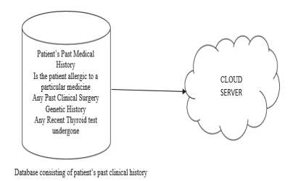

CHAPTER 5
DESIGN AND ANALYSIS

5.1 UML INTRODUCTION
The UML is a graphical language for visualizing, specifying, constructing, and documenting the artifacts of a software-intensive system. The UML gives you a standard way to write a system's blueprints, covering conceptual things, such as business processes and system functions, as well as concrete things, such as classes written in a specific programming language, database schemas, and reusable software components.

Model
A model is a simplification of reality. A model provides the blueprints of a system. A model may be structural, emphasizing the organization of the system, or it may be behavioral, emphasizing the dynamics of the system.

Why do we model

We build models so that we can better understand the system we are developing.
Through modeling, we achieve four aims.
- Models help us to visualize a system as it is or as we want it to be.
- Models permit us to specify the structure or behavior of a system.
- Models give us a template that guides us in constructing a system.
- Models document the decisions we have made.

We build models of complex systems because we cannot comprehend such a system in its entirety.

Principles of Modeling

There are four basic principles of model
- The choice of what models to create has a profound influence on how a problem is attacked and how a solution is shaped.
- Every model may be expressed at different levels of precision.
- The best models are connected to reality.
- No single model is sufficient. Every nontrivial system is best approached through a small set of nearly independent models.

Object Oriented Modeling

In software, there are several ways to approach a model. The two most common ways are
- Algorithmic perspective
- Object-oriented perspective

Algorithmic Perspective
The traditional view of software development takes an algorithmic perspective. In this approach, the main building block of all software is the procedure or function.
- This view leads developers to focus on issues of control and the decomposition of larger algorithms into smaller ones.
- As requirements change and the system grows, systems built with an algorithmic focus turn out to be very hard to maintain.

Object-oriented perspective
- The contemporary view of software development takes an object-oriented perspective. In this approach, the main building block of all software systems is the object or class.
- A class is a description of a set of common objects. Every object has identity, state, and behavior. Object-oriented development provides the conceptual foundation for assembling systems out of components using technology such as Java Beans or COM+.

An Overview of UML
The Unified Modeling Language is a standard language for writing software blueprints. The UML may be used to visualize, specify, construct, and document the artifacts of a software-intensive system.
- The UML is appropriate for modeling systems ranging from enterprise information systems to distributed Web-based applications and even to hard real time embedded systems. It is a very expressive language, addressing all the views needed to develop and then deploy such systems.

The UML is a language for
- Visualizing
- Specifying
- Constructing
- Documenting
- Visualizing The UML is more than just a bunch of graphical symbols. Rather, behind each symbol in the UML notation is a well-defined semantics. In this manner, one developer can write a model in the UML, and another developer, or even another tool, can interpret that model unambiguously
- Specifying means building models that are precise, unambiguous, and complete.
- Constructing the UML is not a visual programming language, but its models can be directly connected to a variety of programming languages
- Documenting a healthy software organization produces all sorts of artifacts in addition to raw executable code. These artifacts include
  - Requirements
  - Architecture
  - Design
  - Source code
  - Project plans
  - Tests
  - Prototypes
  - Releases
To understand the UML, you need to form a conceptual model of the language, and this requires learning three major elements:
- Things
- Relationships
- Diagrams
Things in the UML
There are four kinds of things in the UML:
- Structural things
- Behavioral things
- Grouping things
- Annotational things
Structural things are the nouns of UML models. These are the mostly static parts of a model, representing elements that are either conceptual or physical. In all, there are seven kinds of structural things.
- Classes
- Interfaces
- Collaborations
- Use cases
- Active classes
- Components
- Nodes
- Class is a description of a set of objects that share the same attributes, operations, relationships, and semantics. A class implements one or more interfaces. Graphically, a class is rendered as a rectangle, usually including its name, attributes, and operations.
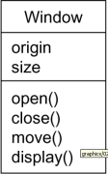

- Interface
- Interface is a collection of operations that specify a service of a class or component. An interface therefore describes the externally visible behavior of that element. An interface might represent the complete behavior of a class or component or only a part of that behavior.

An interface is rendered as a circle together with its name. An interface rarely stands alone. Rather, it is typically attached to the class or component that realizes the interface
- Collaboration defines an interaction and is a society of roles and other elements that work together to provide some cooperative behavior that's bigger than the sum of all the elements. Therefore, collaborations have structural, as well as behavioral, dimensions. A given class might participate in several collaborations. Graphically, a collaboration is rendered as an ellipse with dashed lines, usually including only its name
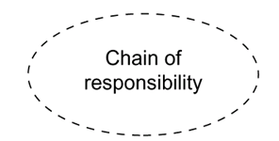

- Use case
- Use case is a description of set of sequence of actions that a system performs that yields an observable result of value to a particular actor
- Use case is used to structure the behavioral things in a model.
- A use case is realized by a collaboration. Graphically, a use case is rendered as an ellipse with solid lines, usually including only its name
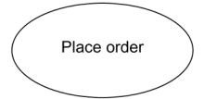

- Active class is just like a class except that its objects represent elements whose behavior is concurrent with other elements. Graphically, an active class is rendered just like a class, but with heavy lines, usually including its name, attributes, and operations
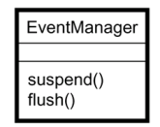

- Component is a physical and replaceable part of a system that conforms to and provides the realization of a set of interfaces. Graphically, a component is rendered as a rectangle with tabs
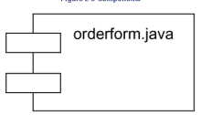
- Node is a physical element that exists at run time and represents a computational resource, generally having at least some memory and, often, processing capability. Graphically, a node is rendered as a cube, usually including only its name
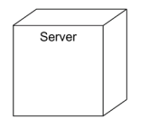

Behavioral Things are the dynamic parts of UML models. These are the verbs of a model, representing behavior over time and space. In all, there are two primary kinds of behavioral things
- a. Interaction b. state machine
- Interaction
- Interaction is a behavior that comprises a set of messages exchanged among a set of objects within a particular context to accomplish a specific purpose An interaction involves a number of other elements, including messages, action sequences and links. Graphically a message is rendered as a directed line, almost always including the name of its operation
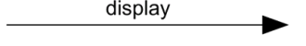

State Machine
- State machine is a behavior that specifies the sequences of states an object or an interaction goes through during its lifetime in response to events, together with its responses to those events
- State machine involves a number of other elements, including states, transitions, events andactivities
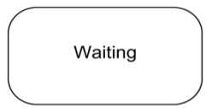
- Graphically, a state is rendered as a rounded rectangle, usually including its name and its substates

Grouping Things:-
- Are the organizational parts of UML models. These are the boxes into which a model can be decomposed.
- There is one primary kind of grouping thing, namely, packages.

Package:-
- A package is a general-purpose mechanism for organizing elements into groups. Structural things, behavioral things, and even other grouping things may be placed in a package
- Graphically, a package is rendered as a tabbed folder, usually including only its name and, sometimes, its contents
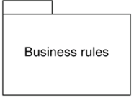

Annotational things are the explanatory parts of UML models. These are the comments you may apply to describe about any element in a model.

- A note is simply a symbol for rendering constraints and comments attached to an element or a collection of elements.
- Graphically, a note is rendered as a rectangle with a dog-eared corner, together with a textual or graphical comment
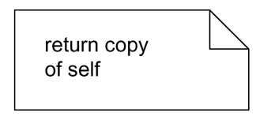

Relationships in the UML: There are four kinds of relationships in the UML:
- Dependency
- Association
- Generalization
- Realization

Dependency is a semantic relationship between two things in which a change to one thing may affect the semantics of the other thing. Graphically a dependency is rendered as a dashed line, possibly directed, and occasionally including a label

Association is a structural relationship that describes a set of links, a link being a connection among objects.
Graphically an association is rendered as a solid line, possibly directed, occasionally including a label, and often containing other adornments, such as multiplicity and role names
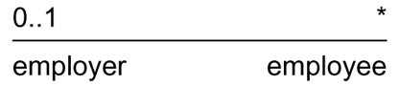

Aggregation is a special kind of association, representing a structural relationship between a whole and its parts. Graphically, a generalization relationship is rendered as a solid line with a hollow arrowhead pointing to the parent
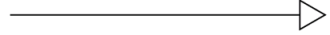

Realization is a semantic relationship between classifiers, wherein one classifier specifies a contract that another classifier guarantees to carry out. Graphically a realization relationship is rendered as a cross between a generalization and a dependency relationship
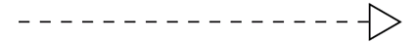

Diagrams in the UML

- Diagram is the graphical presentation of a set of elements, most often rendered as a connected graph of vertices (things) and arcs (relationships).
- In theory, a diagram may contain any combination of things and relationships.
- For this reason, the UML includes nine such diagrams:
            - Use case diagram
            - Class diagram
            - Sequence diagram
            - Collaboration diagram
            - Statechart diagram
            - Activity diagram
            - Component diagram
            - Deployment diagram

Use case diagram
- A use case diagram shows a set of use cases and actors and their relationships
- Use case diagrams address the static use case view of a system.

These diagrams are especially important in organizing and modeling the behaviors of a system.

Class diagram
- A class diagram shows a set of classes, interfaces, and collaborations and their relationships.
- Class diagrams that include active classes address the static process view of a system.

Interaction Diagrams
Both sequence diagrams and collaboration diagrams are kinds of interaction diagrams. Interaction diagrams address the dynamic view of a system
A sequence diagram is an interaction diagram that emphasizes the time-ordering of messages
A collaboration diagram is an interaction diagram that emphasizes the structural organization of the objects that send and receive messages
Sequence diagrams and collaboration diagrams are isomorphic, meaning that you can take one and transform it into the other

Statechart diagram
- A statechart diagram shows a state machine, consisting of states, transitions, events, and activities
- Statechart diagrams address the dynamic view of a system
- They are especially important in modeling the behavior of an interface, class, or collaboration and emphasize the event-ordered behavior of an object

Activity diagram
- An activity diagram is a special kind of a statechart diagram that shows the flow from activity to activity within a system. Activity diagrams address the dynamic view of a system. They are especially important in modeling the function of a system and emphasize the flow of control among objects.

Component diagram
- A component diagram shows the organizations and dependencies among a set of components.
- Component diagrams address the static implementation view of a system
- They are related to class diagrams in that a component typically maps to one or more classes, interfaces, or collaborations

Deployment diagram
- A deployment diagram shows the configuration of run-time processing nodes and the components that live on them
- Deployment diagrams address the static deployment view of an architecture.

5.2 USECASE DIAGRAM

5.3 CLASS DIAGRAM
Figure 5.3 Class Diagram

5.4 SEQUENCE DIAGRAM
Figure 5.4.1 Sequence diagram

5.5 ACTIVITY DIAGRAM
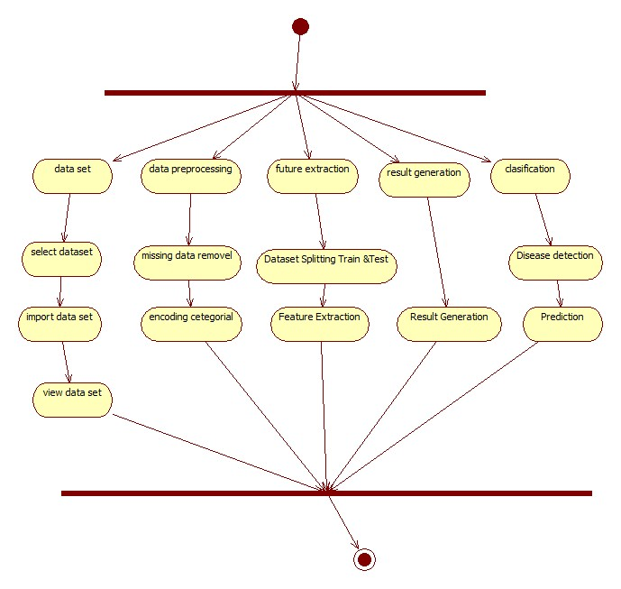
Figure 5.5 Activity diagram
5.6 COMPONENT DIAGRAM
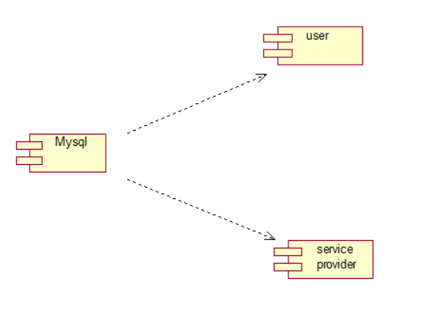
Figure 5.6 Component Diagram

5.7 DEPLOYMENT DIAGRAM
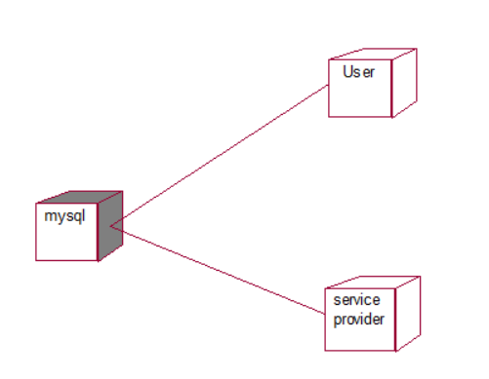
Figure 5.7 Deployment diagram
CHAPTER 6

IMPLEMENTATION

6.1 INTRODUCTION TO PYTHON
Python Technology
Python technology is both a programming language and a platform.
The python Programming Language
The python programming language is a high-level language that can be characterized by all of the following buzzwords:
    - Simple
    - Architecture neutral
    - Object oriented
    - Portable
    - Distributed
    - High performance
    - Interpreted
    - Multithreaded
    - Robust
    - Dynamic
    - Secure
With most programming languages, you either compile or interpret a program so that you can run it on your computer. The Python programming language is unusual in that a program is both compiled and interpreted. With the compiler, first you translate a program into an intermediate language called Python byte codes —the platform-independent codes interpreted by the interpreter on the Python platform. The interpreter parses and runs each Python byte code instruction on the computer. Compilation happens just once; interpretation occurs each time the program is executed. The following figure illustrates how this works.

BENEFITS OF PYTHON
• Presence of Third-Party Modules
• Extensive Support Libraries
• Open Source and Community Development
• Learning Ease and Support Available
• User-friendly Data Structures
• Productivity and Speed
• Highly Extensible and Easily Readable Language.

Python
Python is high level language and it is also integrated version of the program. Python is an object-oriented approach and its main aim to help programmers to write the code clearly, logical code for small and large scale of project.
Python is dynamically typed and garbage collected it also support multiple programming and it is both procedure and object oriented and also functional programming. And structural programming also supported. It has many built in function it also supports filter, map and reduce function. All the machine learning algorithm and the libraries are being supported by the python programming language. Python also support list, dict, sets and other generators. Python code can be run in different platform such as anaconda, PyCharm etc.
The main goal of this programing language is as follows:
• Python is simple, object-oriented programming language.
• The language and implementation should provide support for software engineering principles such as strong type library preset for different machine learning algorithm, and all other algorithm in simple manner.
• Coding will be smooth in python and the data analysis can be easily done in python.
This is so much so to the point where we now have modules and APIs at our disposal, and you can engage in machine learning very easily without almost any knowledge at all of how it works. With the defaults from Scikit-learn, you can get 90-95% accuracy on many tasks right out of the gate. Machine learning is a lot like a car, you do not need to know much about how it works in order to get an incredible amount of utility from it.
Despite the apparent age and maturity of machine learning, I would say there's no better time than now to learn it, since you can actually use it. Machines are quite powerful, the one you are working on can probably do most of this series quickly. Data is also very plentiful lately.
Anaconda
Anaconda is free and open-source distribution of the Python and R programming languages for scientific computing (data science, machine Learning applications, Large- scale data processing, predictive analytics, etc.), that aims to simplify package management and deployment. It is developed and maintained by Anaconda, Inc. The distribution incudes data-science packages suitable for Windows, Linux, and macOS. Packaged versions are required and are managed by the package management system anaconda. This package manager was spun out as a separate open-source package as it ended up being useful on its own and for other things than Python. There is also a small, bootstrap version of Anaconda called Miniconda, which includes only anaconda, Python, the packages they depends on, and a small number of other packages.
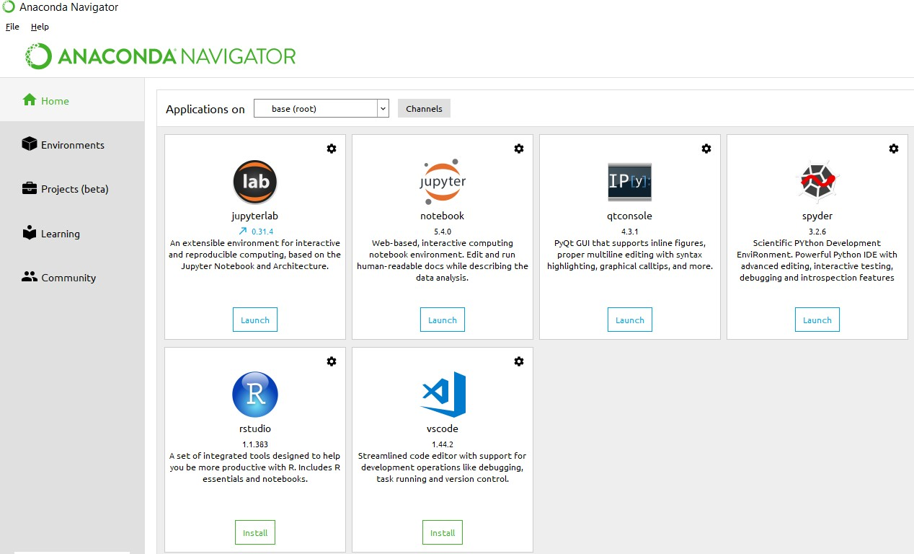
Anaconda Console
import numpy as np
- NumPy is the fundamental package for scientific computing in Python. It is a Python library that provides a multidimensional array object, various derived objects (such as masked arrays and matrices), and an assortment of routines for fast operations on arrays, including mathematical, logical, shape manipulation, sorting, selecting, I/O, discrete Fourier transforms, basic linear algebra, basic statistical operations, random simulation and much more.
- At the core of the NumPy package, is the ndarray object. This encapsulates n-dimensional arrays of homogeneous data types, with many operations being performed in compiled code for performance. There are several important differences between NumPy arrays and the standard Python sequences:
- NumPy arrays have a fixed size at creation, unlike Python lists (which can grow dynamically). Changing the size of an ndarray will create a new array and delete the original.
- The elements in a NumPy array are all required to be of the same data type, and thus will be the same size in memory. The exception: one can have arrays of (Python, including NumPy) objects, thereby allowing for arrays of different sized elements.
import time
This module provides various time-related functions. For related functionality, see also the datetime and calendar modules.
Although this module is always available, not all functions are available on all platforms. Most of the functions defined in this module call platform C library functions with the same name. It may sometimes be helpful to consult the platform documentation, because the semantics of these functions varies among platforms.
An explanation of some terminology and conventions is in order.
The epoch is the point where the time starts, and is platform dependent. For Unix, the epoch is January 1, 1970, 00:00:00 (UTC). To find out what the epoch is on a given platform, look at time.gmtime(0).
import os
This module provides a portable way of using operating system dependent functionality. If you just want to read or write a file see open(), if you want to manipulate paths, see the os. path module, and if you want to read all the lines in all the files on the command line see the fileinput module. For creating temporary files and directories see the tempfile module, and for high-level file and directory handling see the shuttle module.
6.2 TECHNOLOGY USED
6.2.1 Block Chain:
What Is a Hash? A hash is a mathematical function that converts an input of arbitrary length into an encrypted output of a fixed length. Thus, regardless of the original amount of data or file size involved, its unique hash will always be the same size. Moreover, hashes cannot be used to "reverse-engineer" the input from the hashed output since hash functions are "one-way" (like a meat grinder; you can't put the ground beef back into a steak). Still, if you use such a function on the same data, its hash will be identical, so you can validate that the data is the same (i.e., unaltered) if you already know its hash.
Typical hash functions take inputs of variable lengths to return outputs of a fixed length. A cryptographic hash function combines the message-passing capabilities of hash functions with security properties. Hash functions are algorithms that determine how information is encrypted. For example, Secure Hashing Algorithm 256 (SHA-256) goes through a process to encrypt the input it receives by: Converting it to binary Creating hash values Initializing constants Chunking data into bits Creating a message schedule Running a compression loop Modifying the final values Using SHA-256, the word “Hello” will produce an output that is the same number of characters (64) as "Hello world" and “Hello John." However, the hash will be significantly different for all three—keep in mind that capital letters change the hash also:
The function used to generate the hash is deterministic, meaning it will produce the same result each time the same input is used. SHA 256 can generate a hashed output in milliseconds with very little computing power, but it also makes determining the input difficult. This makes hashing ideal for securing cryptocurrency because it would take thousands of years to reverse the encryption to determine the original input with modern technology. Hash functions are commonly used data structures in computing systems for tasks such as checking the integrity of messages and authenticating information. Cryptographic hash functions add security features, making detecting the contents of a message or information more difficult. In particular, cryptographic hash functions exhibit these three properties: They are collision-free: This means that no two different input hashes should map to the same output hash. They can be hidden: It is difficult to guess the input value for a hash function from its output. They should be puzzle-friendly: It should be difficult to select an input that provides a predefined output. Thus, the input should be selected from a distribution that's as wide as possible.

6.2.2 Federated Learning
Federated learning (often referred to as collaborative learning) is a decentralized approach to training machine learning models. It doesn’t require an exchange of data from client devices to global servers. Instead, the raw data on edge devices is used to train the model locally, increasing data privacy. The final model is formed in a shared manner by aggregating the local updates.
Here’s why federated learning is important.
- Privacy: In contrast to traditional methods where data is sent to a central server for training, federated learning allows for training to occur locally on the edge device, preventing potential data breaches.
- Data security: Only the encrypted model updates are shared with the central server, assuring data security. Additionally, secure aggregation techniques such as Secure Aggregation Principle allow the decryption of only aggregated results.
- Access to heterogeneous data: Federated learning guarantees access to data spread across multiple devices, locations, and organizations. It makes it possible to train models on sensitive data, such as financial or healthcare data while maintaining security and privacy. And thanks to greater data diversity, models can be made more generalizable.

WHAT IS DATA SCIENCE?
To manipulate data and extract the important part of data is called Data Science.
Data science is a multidisciplinary blend of data inference, algorithm development, and technology in order to solve analytically complex problems.
At the core is data. Troves of raw information, streaming in and stored in enterprise data warehouses. Much to learn by mining it. Advanced capabilities we can build with it.
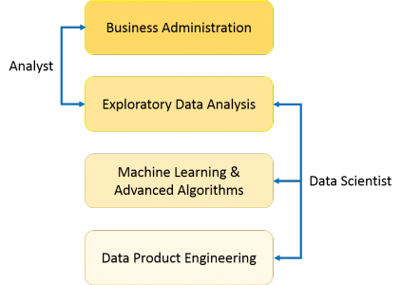

MEANING OF DATA SCIENCE
Data science is the field of study that combines domain expertise, programming skills, and knowledge of math and statistics to extract meaningful insights from data. Data science practitioners apply machine learning algorithms to numbers, text, images, video, audio, and more to produce artificial intelligence (AI) systems that perform tasks which ordinarily require human intelligence. In turn, these systems generate insights that analysts and business users translate into tangible business value.
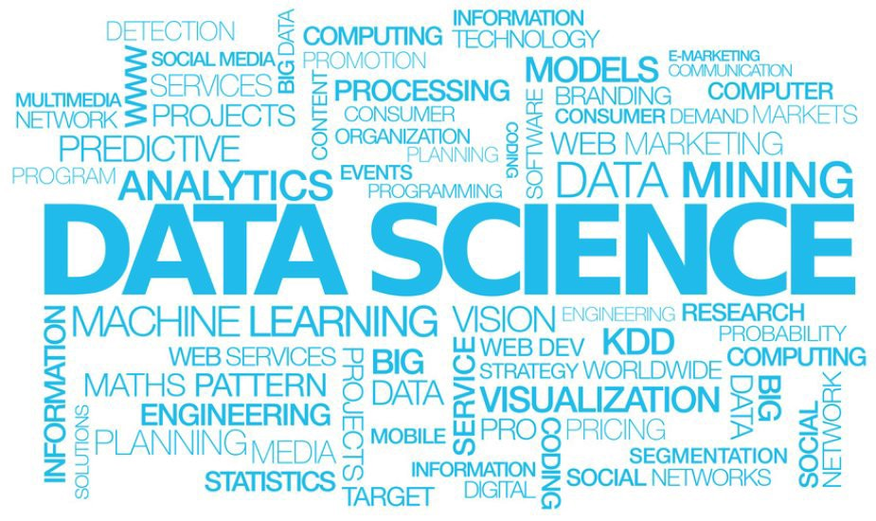

DEFINE DATA SCIENCE COMPONENTS
Basically, here three component of data science-
- Data Management
- Data Analytics
- Machine Learning
Data Management:
Data Management is a comprehensive collection of practices, concepts, procedures, processes, and a wide range of accompanying systems that allow for an organization to gain control of its data resources.
- Data Storage and Big Data.
- Business Intelligence and Analytics.
- Metadata Management.

Data Analytics:
Data analytics is the science of analyzing raw data in order to make conclusions about that information. Many of the techniques and processes of data analytics have been automated into mechanical processes and algorithms that work over raw data for human consumption.

Machine Learning:
Machine Learning (ML) is basically that field of computer science with the help of which computer systems can provide sense to data in much the same way as human beings do. In simple words, ML is a type of artificial intelligence that extract patterns out of raw data by using an algorithm or method. The key focus of ML is to allow computer systems to learn from experience without being explicitly programmed or human intervention.
DATA
Data is a set of values of qualitive or quantitative variables. It is information in raw or unorganized form. It may be fact, figure, character symbols etc.
- Qualitative -Categorical or Nominal:
  - Discrete Data
  - Continuous Data
- Quantitative -Measurable or Countable:
  - Attribute
  - Nominal
  - Ordinal
Information:
Meaningful or organized data is information.
Big Data:
Extremely large data sets that may be analyzed computationally to reveal patterns, trends and associations, especially relating to human behavior and interactions.
Design distributed systems that manage big data using HADOOP and related technologies.
Big data cannot manage by RDBMS
TYPES OF DATA
There are three types of dataset-
- STRUCTURED DATA
- SEMI-STRUCTURED DATA
- UNSTRUCTURED DATA
Structured Data:
Data which can be stored in database SQL in table with rows and columns are called structured data.
Only 5 to 10 % of all informatics data.

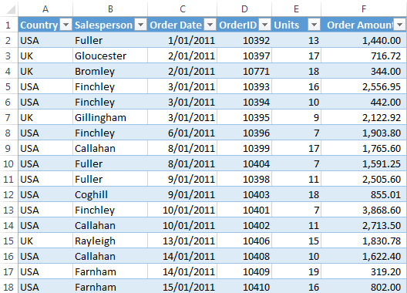
Semi-Structured Data:
Doesn’t reside in a relational database but that does have some organizational properties that make it easier to analyze.
CSV, XML AND JSON documents are semi-structured documents, NoSQL databases are considered as semi-structured.
A few parts of data(5 to 10 %).

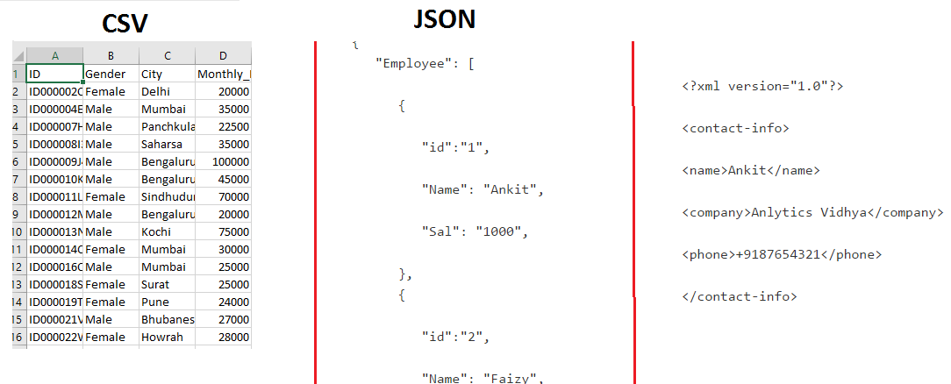
Unstructured Data:
Unstructured data represent around 80% of data. It often includes text and multimedia content.
Example: e-mail messages, word processing documents, videos, photos, audio files, presentation, webpages and many other kinds of business documents.
Some example of machine-generated unstructured data :
- Satellite images
- Scientific data
- Photographs and video
- Rader or Sonar data
Some example of human-generated unstructured data:
- Text internal
- Social media data
- Mobile data
- Website content

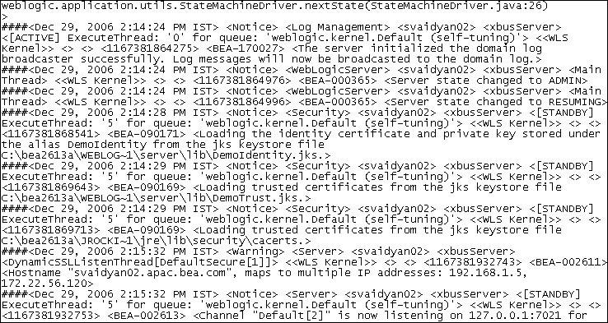
DATA ANALYTICS
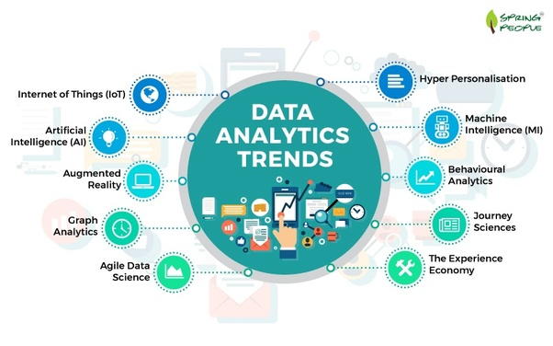
Data Analytics is the process of examining data sets in order to draw conclusion about the information it contains.
increasingly with the aid of specialized systems and software. Data analytics technologies and techniques are widely used in commercial industries to enable organizations to make more-informed business decisions and by scientists and researchers to verify or disprove scientific models, theories and hypotheses.
Analytics is not a tool of technology, rather it is the way of thinking and acting on data.
TYPES OF DATA ANALYTICS
Data analytics are of three types those are: -
- Descriptive Analytics
- Predictive Analytics
- Prescriptive Analytics
Descriptive Analytics:
90% of organizations today use descriptive analytics which is the most basic form of analytics. The simplest way to define descriptive analytics is that, it answers the question “What has happened?”. This type of analytics, analyses the data coming in real-time and historical data for insights on how to approach the future. The main objective of descriptive analytics is to find out the reasons behind precious success or failure in the past. The ‘Past’ here, refers to any particular time in which an event had occurred and this could be a month ago or even just a minute ago. The vast majority of big data analytics used by organizations falls into the category of descriptive analytics.
Predictive Analytics:
The subsequent step in data reduction is predictive analytics. Analyzing past data patterns and trends can accurately inform a business about what could happen in the future. This helps in setting realistic goals for the business, effective planning and restraining expectations. Predictive analytics is used by businesses to study the data and ogle into the crystal ball to find answers to the question “What could happen in the future based on previous trends and patterns?”
Prescriptive Analytics:
Big data might not be a reliable crystal ball for predicting the exact winning lottery numbers but it definitely can highlight the problems and help a business understand why those problems occurred. Businesses can use the data-backed and data-found factors to create prescriptions for the business problems, that lead to realizations and observations.
PROCESS OF ANALYZING THE DATA IN DATA SCIENCE
Data goes through various process during data analytics in data Science. Those are given below
DATA SCIENCE PROCESS OR LIFE CYCLE
- Problem Identification
- Hypothesis formulation
- Data Collection
- Data Exploration/Preparation
- Model Building
- Model Validation and Evaluation
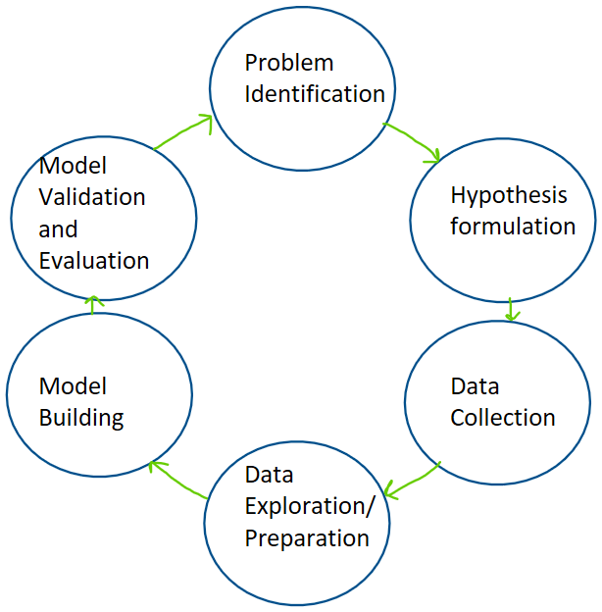
DATA MANAGEMENT TOOLS
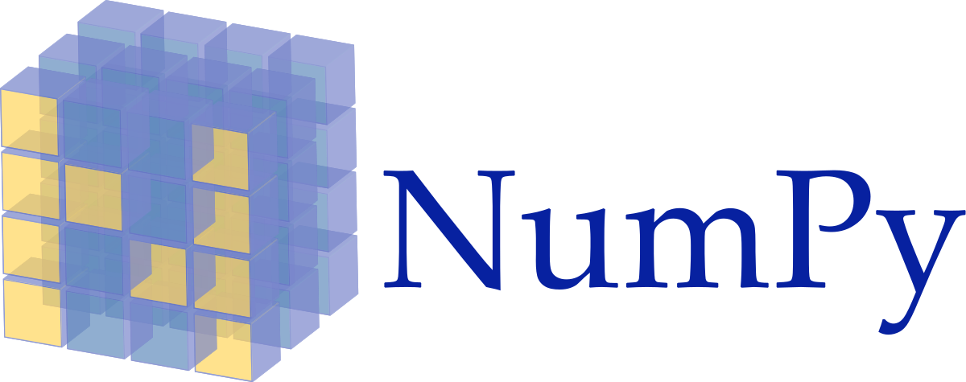
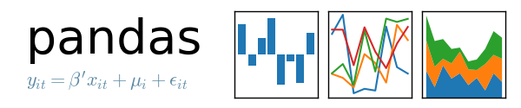


TOP 10 PYTHON LIBRARIES
One of the reason PYTHON Is mostly popular among developers is its wide range of libraries. We can’t even count how many libraries it has but We will be considering the following 10 libraries:
- NUMPY
- PANDAS
- MATPLOTLIB
- SEABORN
- IPYTHON
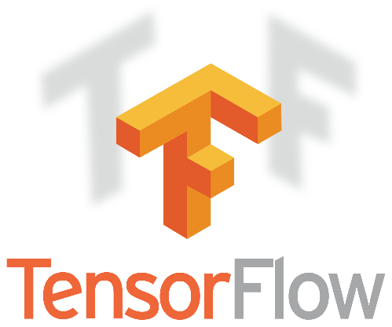
- TENSORFLOW
- SCIKIT-LEARN
- KERAS
- PYTORCH
- SCIPY


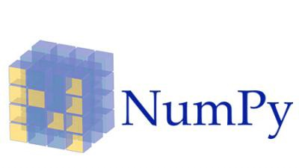

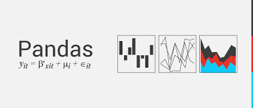

JUPETER NOTEBOOK
Jupiter Notebook is an interface we use to write python programs. It is Widely popular because most of the popular python libraries are pre-installed in it.
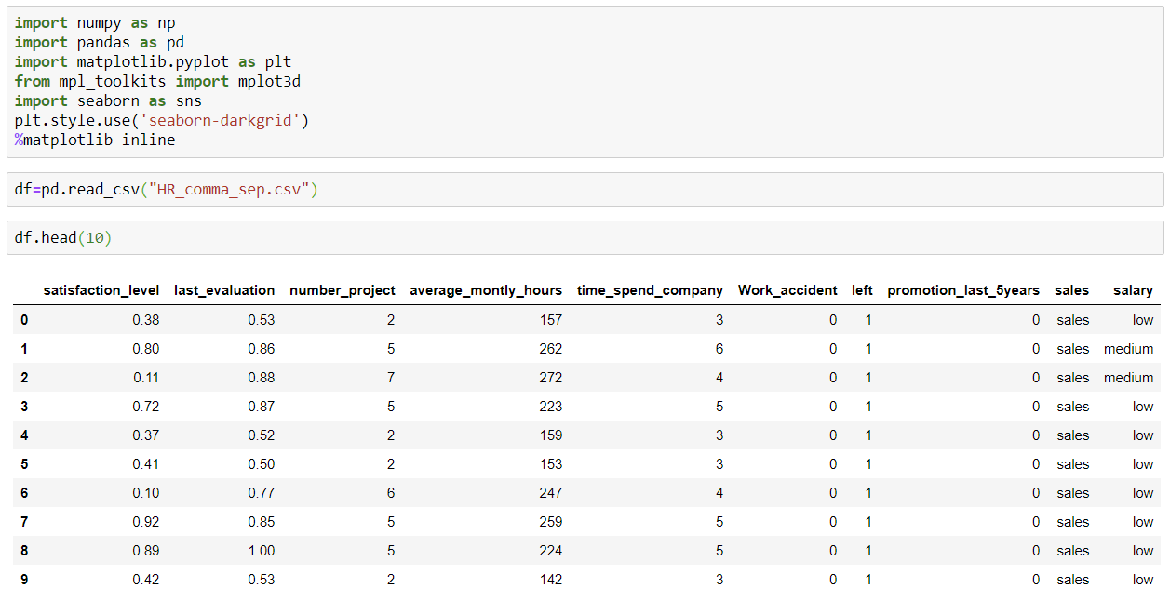
And we can write and run part of a code written in a code cell. So, it is very helpful for debugging.
6.2 SAMPLE CODE
from tkinter import messagebox
from tkinter import *
from tkinter import simpledialog
import tkinter
from tkinter import filedialog
from tkinter.filedialog import askopenfilename
import numpy as np
import matplotlib.pyplot as plt
import pandas as pd
from sklearn.preprocessing import normalize
from sklearn.metrics import accuracy_score
from sklearn.model_selection import train_test_split
import os
from sklearn.metrics import confusion_matrix
from sklearn.metrics import accuracy_score
from sklearn.tree import DecisionTreeClassifier
from sklearn.naive_bayes import GaussianNB
from sklearn import svm
from sklearn.metrics import precision_score
from sklearn.metrics import recall_score
from sklearn.metrics import f1_score
import seaborn as sns
import webbrowser
from sklearn.ensemble import RandomForestClassifier
from sklearn.linear_model import LogisticRegression
from sklearn.neural_network import MLPClassifier
from sklearn.ensemble import AdaBoostClassifier
from keras.utils.np_utils import to_categorical
from keras.layers import MaxPooling2D
from keras.layers import Dense, Dropout, Activation, Flatten
from keras.layers import Convolution2D
from keras.models import Sequential
from keras.models import model_from_json
import pickle
global filename
global X,Y
global dataset
global main
global text
accuracy = []
precision = []
recall = []
fscore = []
global X_train, X_test, y_train, y_test, predict_cls
global classifier
main = tkinter.Tk()
main.title("Detection Of Thyroid Disorders Using Machine Learning Appoarch") #designing main screen
main.geometry("1300x1200")
#fucntion to upload dataset
def uploadDataset():
global filename
global dataset
text.delete('1.0', END)
filename = filedialog.askopenfilename(initialdir="Dataset")
text.insert(END,filename+" loaded\n\n")
dataset = pd.read_csv(filename)
text.insert(END,"Dataset before preprocessing\n\n")
text.insert(END,str(dataset.head()))
text.update_idletasks()
label = dataset.groupby('FLAG').size()
label.plot(kind="bar")
plt.title("Blockchain Fraud Detection Graph 0 means Normal & 1 means Fraud")
plt.show()
#function to perform dataset preprocessing
def trainTest():
global X,Y
global dataset
global X_train, X_test, y_train, y_test
text.delete('1.0', END)
#replace missing values with 0
dataset.fillna(0, inplace = True)
Y = dataset['FLAG'].ravel()
dataset = dataset.values
X = dataset[:,4:dataset.shape[1]-2]
X = normalize(X)
indices = np.arange(X.shape[0])
np.random.shuffle(indices)
X = X[indices]
Y = Y[indices]
X = X[0:5000]
Y = Y[0:5000]
print(Y)
print(X)
text.insert(END,"Dataset after features normalization\n\n")
text.insert(END,str(X)+"\n\n")
text.insert(END,"Total records found in dataset : "+str(X.shape[0])+"\n")
text.insert(END,"Total features found in dataset: "+str(X.shape[1])+"\n\n")
X_train, X_test, y_train, y_test = train_test_split(X, Y, test_size=0.2)
text.insert(END,"Dataset Train and Test Split\n\n")
text.insert(END,"80% dataset records used to train ML algorithms : "+str(X_train.shape[0])+"\n")
text.insert(END,"20% dataset records used to train ML algorithms : "+str(X_test.shape[0])+"\n")
def calculateMetrics(algorithm, predict, y_test):
a = accuracy_score(y_test,predict)*100
p = precision_score(y_test, predict,average='macro') * 100
r = recall_score(y_test, predict,average='macro') * 100
f = f1_score(y_test, predict,average='macro') * 100
accuracy.append(a)
precision.append(p)
recall.append(r)
fscore.append(f)
text.insert(END,algorithm+" Accuracy : "+str(a)+"\n")
text.insert(END,algorithm+" Precision : "+str(p)+"\n")
text.insert(END,algorithm+" Recall : "+str(r)+"\n")
text.insert(END,algorithm+" FScore : "+str(f)+"\n\n")
def runLogisticRegression():
global X,Y, X_train, X_test, y_train, y_test
global accuracy, precision,recall, fscore
accuracy.clear()
precision.clear()
recall.clear()
fscore.clear()
text.delete('1.0', END)
lr = LogisticRegression()
lr.fit(X, Y)
predict = lr.predict(X_test)
calculateMetrics("Logistic Regression", predict, y_test)
def runMLP():
mlp = MLPClassifier()
mlp.fit(X_train, y_train)
predict = mlp.predict(X_test)
calculateMetrics("MLP", predict, y_test)
def runRF():
global predict_cls
rf = RandomForestClassifier()
rf.fit(X_train, y_train)
predict = rf.predict(X_test)
predict_cls = rf
calculateMetrics("Random Forest", predict, y_test)
def predict():
global predict_cls
text.delete('1.0', END)
filename = filedialog.askopenfilename(initialdir="Dataset")
dataset = pd.read_csv(filename)
dataset.fillna(0, inplace = True)
dataset = dataset.values
X = dataset[:,4:dataset.shape[1]-2]
X1 = normalize(X)
prediction = predict_cls.predict(X1)
print(prediction)
for i in range(len(prediction)):
if prediction[i] == 0:
text.insert(END,"Test DATA : "+str(X[i])+" ===> PREDICTED AS NORMAL\n\n")
else:
text.insert(END,"Test DATA : "+str(X[i])+" ===> PREDICTED AS Disease\n\n")
font = ('times', 16, 'bold')
title = Label(main, text='Detection Of Thyroid Disorders Using Machine Learning Appoarch')
title.config(bg='greenyellow', fg='dodger blue')
title.config(font=font)
title.config(height=3, width=120)
title.place(x=0,y=5)
font1 = ('times', 12, 'bold')
text=Text(main,height=20,width=150)
scroll=Scrollbar(text)
text.configure(yscrollcommand=scroll.set)
text.place(x=50,y=120)
text.config(font=font1)
font1 = ('times', 13, 'bold')
uploadButton = Button(main, text="Upload & Preprocess Dataset", command=uploadDataset)
uploadButton.place(x=50,y=550)
uploadButton.config(font=font1)
traintestButton = Button(main, text="Generate Train & Test Model", command=trainTest)
traintestButton.place(x=330,y=550)
traintestButton.config(font=font1)
lrButton = Button(main, text="Run Random Algorithm", command=runRF)
lrButton.place(x=630,y=550)
lrButton.config(font=font1)
mlpButton = Button(main, text="Predict Disease", command=predict)
mlpButton.place(x=950,y=550)
mlpButton.config(font=font1)
main.config(bg='LightSkyBlue')
main.mainloop()
from tkinter import messagebox
from tkinter import *
from tkinter import simpledialog
import tkinter
from tkinter import filedialog
import matplotlib.pyplot as plt
from tkinter.filedialog import askopenfilename
import numpy as np
import os
import pandas as pd
from sklearn.metrics import accuracy_score
from sklearn.model_selection import train_test_split
from sklearn.metrics import confusion_matrix
from sklearn.naive_bayes import GaussianNB
from sklearn import svm
from sklearn.metrics import precision_score
from sklearn.metrics import recall_score
from sklearn.metrics import f1_score
import seaborn as sns
from sklearn.ensemble import RandomForestClassifier
from sklearn.preprocessing import LabelEncoder
from sklearn.preprocessing import StandardScaler
from imblearn.over_sampling import SMOTE
main = tkinter.Tk()
main.title("Thyroid Disease Detection using Machine Learning Algorithms")
main.geometry("1300x1200")
global filename, rf_cls, X, Y
global accuracy, precision, recall, fscore
global X_train, X_test, y_train, y_test
global labels
global label_encoder, scaler
def upload():
global filename, labels, dataset
filename = filedialog.askopenfilename(initialdir="Dataset")
text.delete('1.0', END)
text.insert(END,filename+" loaded\n")
dataset = pd.read_csv(filename)
text.insert(END,str(dataset)+"\n\n")
text.update_idletasks()
labels = np.unique("binaryClass")
label = dataset.groupby('binaryClass').size()
label.plot(kind="bar")
plt.xlabel("P (Thyroid Presence) & N (Normal)")
plt.ylabel("Count")
plt.title("Normal & Thyroid Patient Graph")
plt.show()
def preprocess():
text.delete('1.0', END)
global dataset, X, Y, label_encoder, scaler
global X_train, X_test, y_train, y_test
label_encoder = []
dataset.fillna(0, inplace = True)
dataset["age"] = dataset["age"].astype(float)
dataset["TSH"] = dataset["TSH"].astype(float)
dataset["T3"] = dataset["T3"].astype(float)
dataset["TT4"] = dataset["TT4"].astype(float)
dataset["T4U"] = dataset["T4U"].astype(float)
dataset["FTI"] = dataset["FTI"].astype(float)
columns = dataset.columns
types = dataset.dtypes.values
print(dataset.info())
for i in range(len(types)):
name = types[i]
if name == 'object':
le = LabelEncoder()
dataset[columns[i]] = pd.Series(le.fit_transform(dataset[columns[i]].astype(str)))
label_encoder.append(le)
print(dataset.info())
scaler = StandardScaler()
text.insert(END,"Dataset Preprocessing & Normalization Process Completed\n\n")
text.insert(END,str(dataset)+"\n\n")
dataset = dataset.values
X = dataset[:,0:dataset.shape[1]-1]
Y = dataset[:,dataset.shape[1]-1]
print(X)
print(Y)
X = scaler.fit_transform(X)
indices = np.arange(X.shape[0])
np.random.shuffle(indices)
X = X[indices]
Y = Y[indices]
sm = SMOTE(random_state=42)
X, Y = sm.fit_resample(X, Y)
X_train, X_test, y_train, y_test = train_test_split(X, Y, test_size=0.2)
text.insert(END,"Total records found in dataset : "+str(X.shape[0])+"\n\n")
text.insert(END,"Dataset split for train and test\n\n")
text.insert(END,"80% dataset records used to train Machine Learning Algorithms : "+str(X_train.shape[0])+"\n")
text.insert(END,"20% dataset records used to test Machine Learning Algorithms : "+str(X_test.shape[0])+"\n")
#function to calculate all metrics
def calculateMetrics(algorithm, y_test, predict):
a = accuracy_score(y_test,predict)*100
p = precision_score(y_test, predict,average='macro') * 100
r = recall_score(y_test, predict,average='macro') * 100
f = f1_score(y_test, predict,average='macro') * 100
accuracy.append(a)
precision.append(p)
recall.append(r)
fscore.append(f)
text.insert(END,algorithm+" Accuracy : "+str(a)+"\n")
text.insert(END,algorithm+" Precision : "+str(p)+"\n")
text.insert(END,algorithm+" Recall : "+str(r)+"\n")
text.insert(END,algorithm+" FScore : "+str(f)+"\n\n")
conf_matrix = confusion_matrix(y_test, predict)
label = ["Normal", "Throid Detected"]
ax = sns.heatmap(conf_matrix, xticklabels = label, yticklabels = label, annot = True, cmap="viridis" ,fmt ="g");
ax.set_ylim([0,len(label)])
plt.title(algorithm+" Confusion matrix")
plt.ylabel('True class')
plt.xlabel('Predicted class')
plt.show()
def runNaiveBayes():
text.delete('1.0', END)
global X_train, X_test, y_train, y_test
global accuracy, precision, recall, fscore
accuracy = []
precision = []
recall = []
fscore = []

nb_cls = GaussianNB()
nb_cls.fit(X_train, y_train)
predict = nb_cls.predict(X_test)
calculateMetrics("Naive Bayes", y_test, predict)
def runSVM():
svm_cls = svm.SVC()
svm_cls.fit(X_train, y_train)
predict = svm_cls.predict(X_test)
calculateMetrics("SVM", y_test, predict)
def runRF():
global rf_cls
rf_cls = RandomForestClassifier()
rf_cls.fit(X_train, y_train)
predict = rf_cls.predict(X_test)
calculateMetrics("Random Forest", y_test, predict)

def graph():
df = pd.DataFrame([['Naive Bayes','Precision',precision[0]],['Naive Bayes','Recall',recall[0]],['Naive Bayes','F1 Score',fscore[0]],['Naive Bayes','Accuracy',accuracy[0]],
['SVM','Precision',precision[1]],['SVM','Recall',recall[1]],['SVM','F1 Score',fscore[1]],['SVM','Accuracy',accuracy[1]],
['Random Forest','Precision',precision[2]],['Random Forest','Recall',recall[2]],['Random Forest','F1 Score',fscore[2]],['Random Forest','Accuracy',accuracy[2]],

],columns=['Parameters','Algorithms','Value'])
df.pivot("Parameters", "Algorithms", "Value").plot(kind='bar')
plt.show()
def predict():
text.delete('1.0', END)
global rf_cls, scaler, label_encoder
filename = filedialog.askopenfilename(initialdir="Dataset")
dataset = pd.read_csv(filename)
dataset.fillna(0, inplace = True)
columns = dataset.columns
types = dataset.dtypes.values
for i in range(len(columns)):
dataset[columns[i]] = dataset[columns[i]].astype(str)
dataset["age"] = dataset["age"].astype(float)
dataset["TSH"] = dataset["TSH"].astype(float)
dataset["T3"] = dataset["T3"].astype(float)
dataset["TT4"] = dataset["TT4"].astype(float)
dataset["T4U"] = dataset["T4U"].astype(float)
dataset["FTI"] = dataset["FTI"].astype(float)
columns = dataset.columns
types = dataset.dtypes.values
print(dataset.info())
index = 0
for i in range(len(types)):
name = types[i]
if name == 'object':
dataset[columns[i]] = pd.Series(label_encoder[index].fit_transform(dataset[columns[i]].astype(str)))
index = index + 1
print(dataset.info())
dataset = dataset.values
testData = scaler.transform(dataset)
predict = rf_cls.predict(testData)
print(predict)
for i in range(len(predict)):
if predict[i] != 1:
print(str(i)+" "+str(predict[i]))
for i in range(len(predict)):
pred = predict[i]
if pred == 0:
text.insert(END,"Test Data = "+str(dataset[i])+"=====> Predicted AS NORMAL\n\n")
if pred == 0:
text.insert(END,"Test Data = "+str(dataset[i])+"=====> Predicted AS THYROID DETECTED\n\n")
font = ('times', 16, 'bold')
title = Label(main, text='Thyroid Disease Detection using Machine Learning Algorithms')
title.config(bg='firebrick4', fg='dodger blue')
title.config(font=font)
title.config(height=3, width=120)
title.place(x=0,y=5)

font1 = ('times', 12, 'bold')
text=Text(main,height=24,width=150)
scroll=Scrollbar(text)
text.configure(yscrollcommand=scroll.set)
text.place(x=40,y=120)
text.config(font=font1)
font1 = ('times', 13, 'bold')
uploadButton = Button(main, text="Upload Thyroid Dataset", command=upload, bg='#ffb3fe')
uploadButton.place(x=50,y=600)
uploadButton.config(font=font1)
processButton = Button(main, text="Preprocess Dataset", command=preprocess, bg='#ffb3fe')
processButton.place(x=370,y=600)
processButton.config(font=font1)
nbButton1 = Button(main, text="Run Naive Bayes Algorithm", command=runNaiveBayes, bg='#ffb3fe')
nbButton1.place(x=610,y=600)
nbButton1.config(font=font1)
svmButton = Button(main, text="Run SVM Algorithm", command=runSVM, bg='#ffb3fe')
svmButton.place(x=900,y=600)
svmButton.config(font=font1) rfButton = Button(main, text="Run Random Forest Algorithm", command=runRF, bg='#ffb3fe')
rfButton.place(x=50,y=650)
rfButton.config(font=font1)
graphButton = Button(main, text="Comparison Graph", command=graph, bg='#ffb3fe')
graphButton.place(x=360,y=650)
graphButton.config(font=font1)
predictButton = Button(main, text="Predict Disease from Test Data", command=predict, bg='#ffb3fe')
predictButton.place(x=610,y=650)
predictButton.config(font=font1)
main.config(bg='LightSalmon3')
main.mainloop()```

CHAPTER 7

OUTPUT SCREENS
To run project double click on ‘run.bat’ file to get below screen
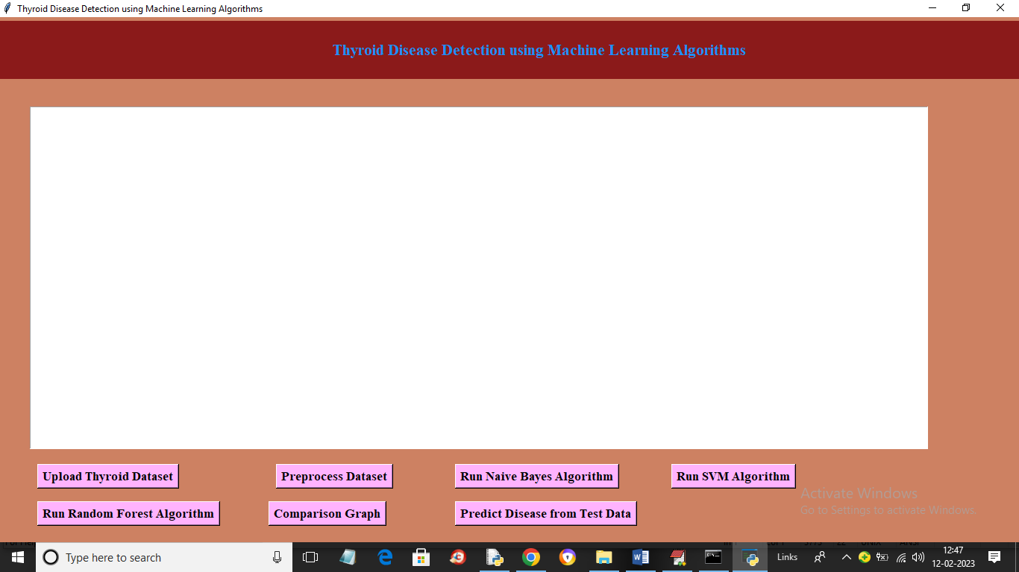
In above screen click on ‘Upload Thyroid Dataset’ button to load dataset and get below output
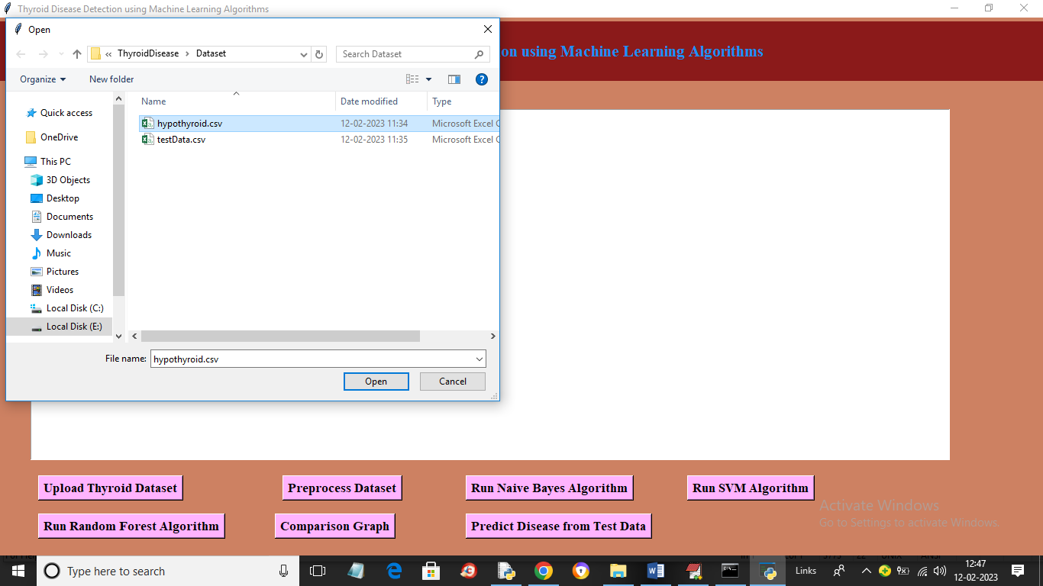
In above screen selecting and uploading thyroid dataset and then click on ‘Open’ button to load dataset and get below output
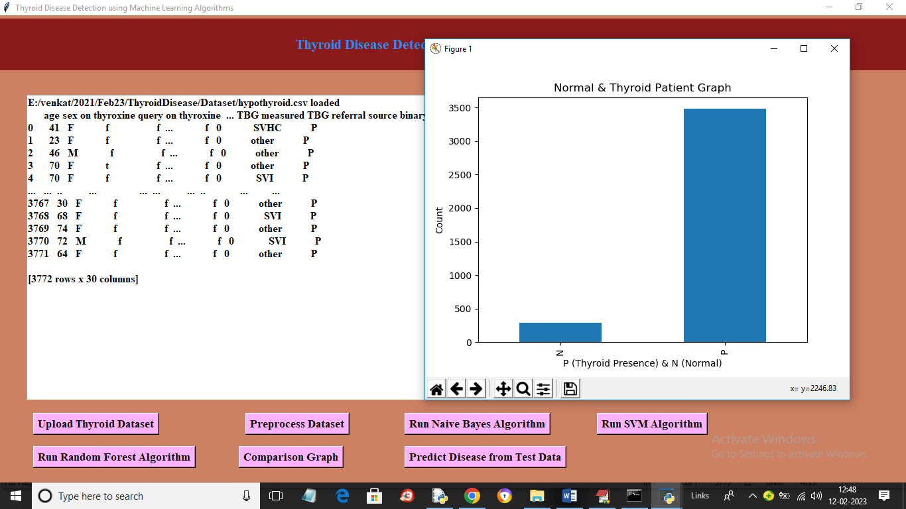
In above screen dataset loaded and in graph x-axis represents N (normal) and P (thyroid presence) and y-axis represents number of records and in above dataset values we can see some are non-numeric and some are numeric and machine learning algorithms accept only numeric values so we need to process dataset to encode non-numeric values to numeric values so click on ‘Preprocess Dataset’ button to get below output
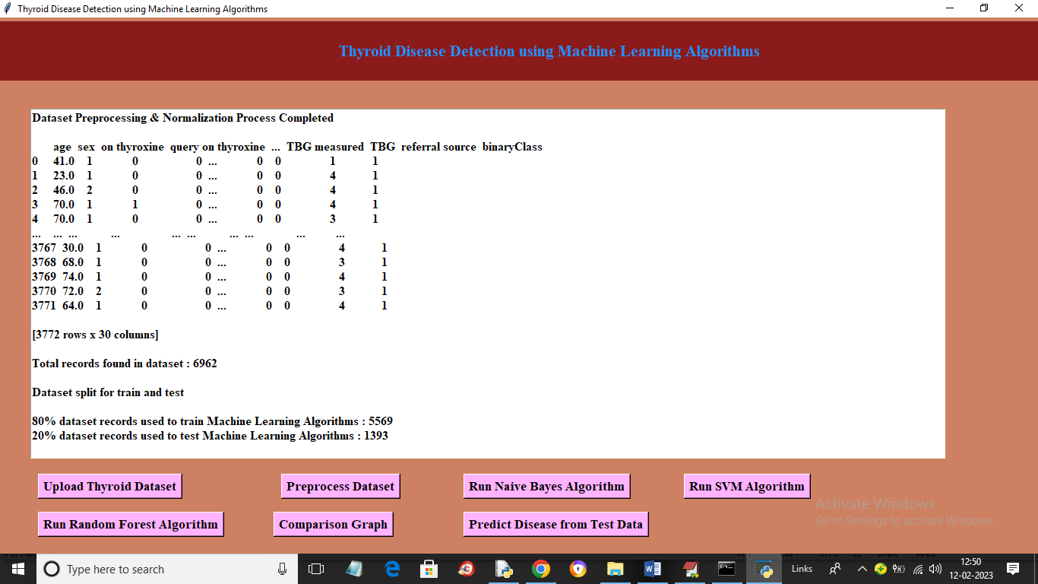
In above screen we can see all values are converted to numeric format and then we can see dataset contains 6962 records where application using 80% records (5569) for training and 1393 (20%) records for testing. Now click on ‘Run Naïve Bayes Algorithm’ button to train Naïve Bayes on 80% dataset and test on 20% data to get below prediction accuracy
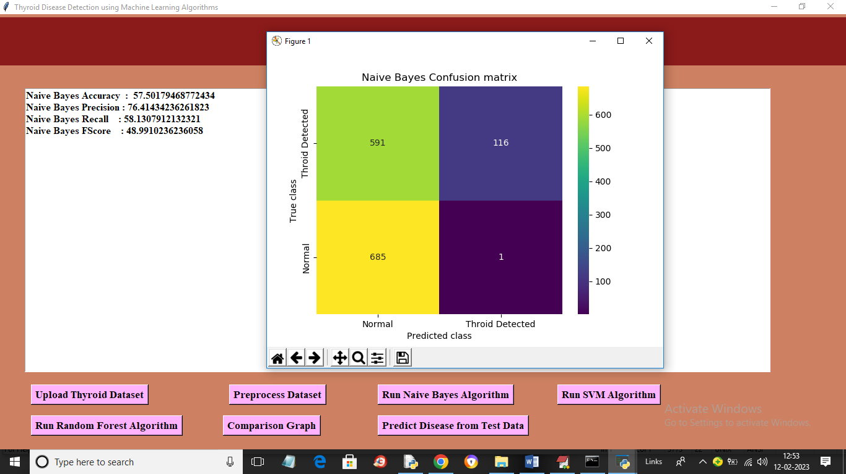
In above screen with Naïve Bayes we got 57% accuracy and we can see other metrics like precision, recall and FSCORE. In confusion matric graph x-axis represents Predicted Labels and y-axis represents True Labels and yellow and light blue colour in diagnol represents correct prediction and dark blue and green box contains incorrect prediction count. Now close above graph and then click on ‘Run SVM Algorithm’ button to get below output
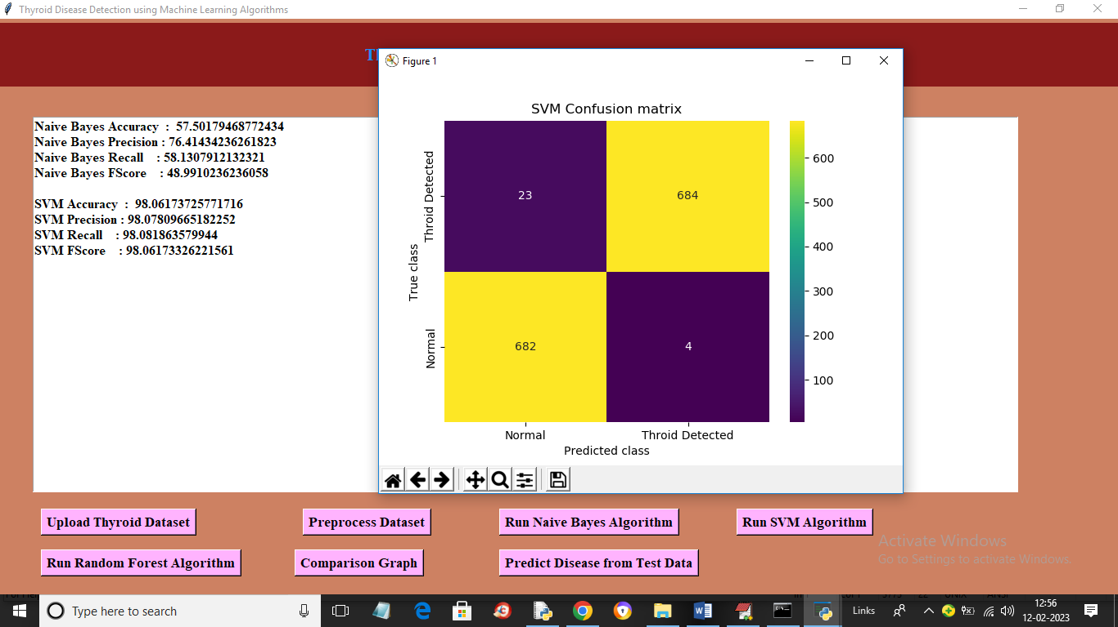
In above screen with SVM we got 98% accuracy and in confusion matrix graph yellow boxes contains correct prediction count and blue boxes contains incorrect prediction count. Now close above graph and then click on ‘Run Random Forest Algorithm’ button to get below output
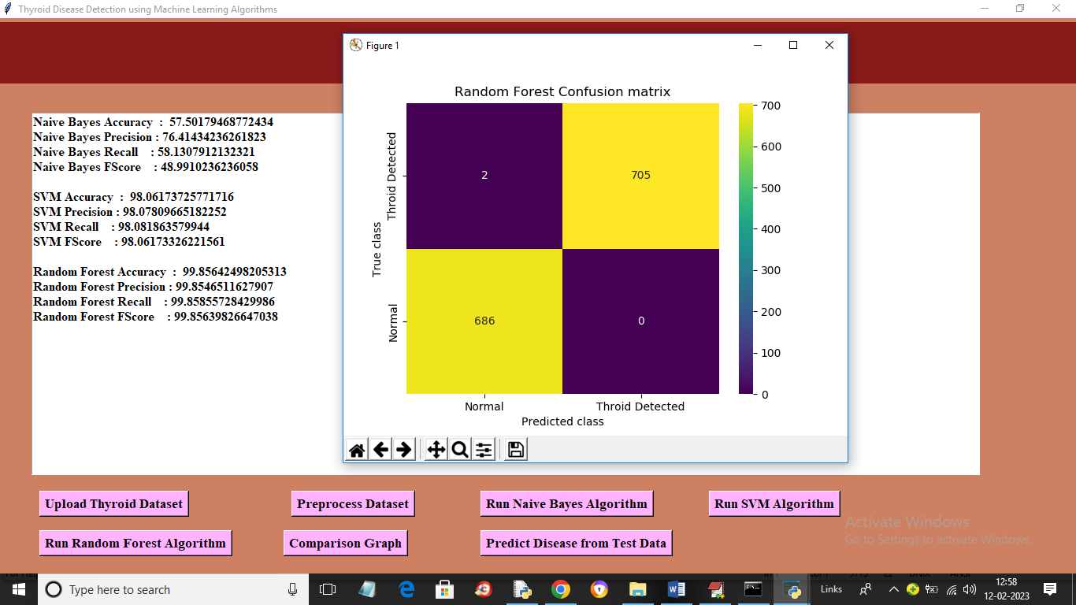
In above screen with Random Forest we got 99% accuracy and now click on ‘Comparison Graph’ button to get below graph
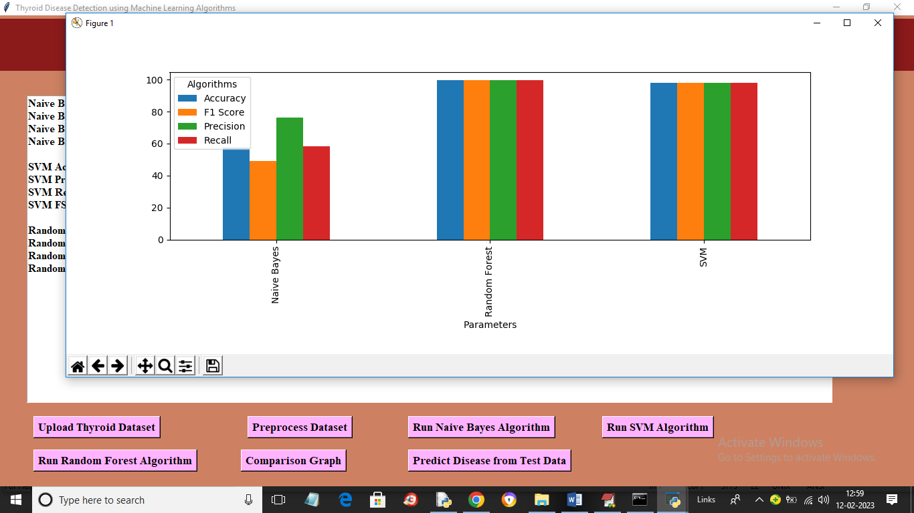
In above graph x-axis represents algorithm names and y-axis represents metric values like accuracy, precision, recall in different bar colour and in all algorithms Random Forest got high accuracy. Now close above graph and then click on ‘Predict Disease from Test Data’ to upload test data and get prediction output
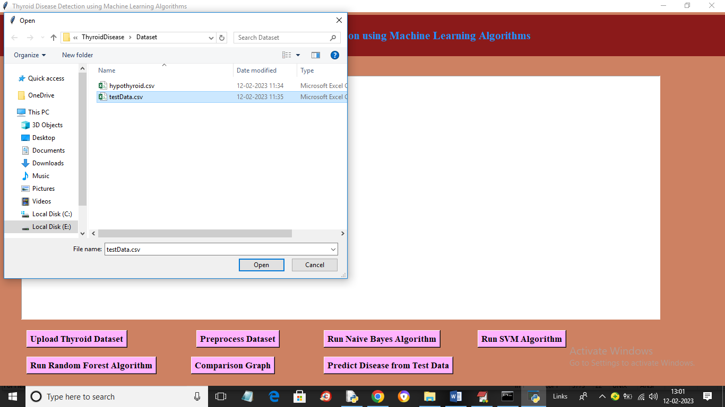
In above screen selecting and uploading testData.csv file and then click on ‘Open’ button to get below output
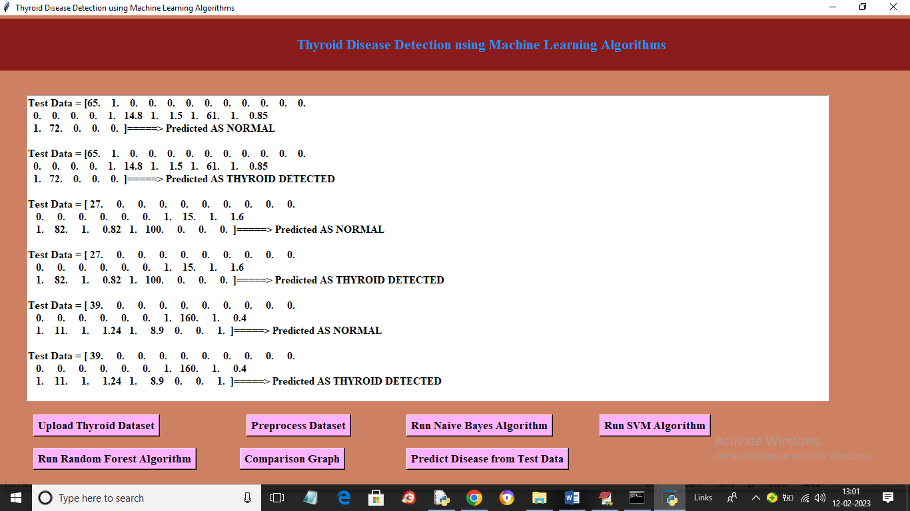
In above screen in square bracket we can see test data and after arrow symbol we can see predicted output

CHAPTER 8

TESTING AND VALIDATION
8.1 INTRODUCTION
The purpose of testing is to discover errors. Testing is the process of trying to discover every conceivable fault or weakness in a work product. It provides a way to check the functionality of components, sub assemblies, assemblies and/or a finished product It is the process of exercising software with the intent of ensuring that the
Software system meets its requirements and user expectations and does not fail in an unacceptable manner. There are various types of test. Each test type addresses a specific testing requirement.

8.2 TYPES OF TESTING

Unit testing
Unit testing involves the design of test cases that validate that the internal program logic is functioning properly, and that program inputs produce valid outputs. All decision branches and internal code flow should be validated. It is the testing of individual software units of the application .it is done after the completion of an individual unit before integration. This is a structural testing, that relies on knowledge of its construction and is invasive. Unit tests perform basic tests at component level and test a specific business process, application, and/or system configuration. Unit tests ensure that each unique path of a business process performs accurately to the documented specifications and contains clearly defined inputs and expected results.

Integration testing
Integration tests are designed to test integrated software components to determine if they actually run as one program. Testing is event driven and is more concerned with the basic outcome of screens or fields. Integration tests demonstrate that although the components were individually satisfaction, as shown by successfully unit testing, the combination of components is correct and consistent. Integration testing is specifically aimed at exposing the problems that arise from the combination of components.

Functional test
Functional tests provide systematic demonstrations that functions tested are available as specified by the business and technical requirements, system documentation, and user manuals.
Functional testing is centered on the following items:
Valid Input : identified classes of valid input must be accepted.
Invalid Input :identified classes of invalid input must be rejected.
Functions : identified functions must be exercised.
Output : identified classes of application outputs must be exercised.
Systems/Procedures: interfacing systems or procedures must be invoked.
Organization and preparation of functional tests is focused on requirements, key functions, or special test cases. In addition, systematic coverage pertaining to identify Business process flows; data fields, predefined processes, and successive processes must be considered for testing. Before functional testing is complete, additional tests are identified and the effective value of current tests is determined.

System Test
System testing ensures that the entire integrated software system meets requirements. It tests a configuration to ensure known and predictable results. An example of system testing is the configuration-oriented system integration test. System testing is based on process descriptions and flows, emphasizing pre-driven process links and integration points.

White Box Testing
White Box Testing is a testing in which in which the software tester has knowledge of the inner workings, structure and language of the software, or at least its purpose. It is purpose. It is used to test areas that cannot be reached from a black box level.

Black Box Testing
Black Box Testing is testing the software without any knowledge of the inner workings, structure or language of the module being tested. Black box tests, as most other kinds of tests, must be written from a definitive source document, such as specification or requirements document, such as specification or requirements document. It is a testing in which the software under test is treated, as a black box .you cannot “see” into it. The test provides inputs and responds to outputs without considering how the software works.

CHAPTER 9

9.1 CONCLUSION
Thus the proposed work will be very much useful to identify the thyroid disease in a patient at an early stage using classification based machine learning techniques. These algorithms give various levels of precision and accuracy. These methods also aid in decreasing the unwanted redundant data from the patient’s database. The algorithms used in the proposed model are cost effective and also have good output performance and speed. These classification methods make the treatment of the thyroid patient simple by reducing further complex procedures with an affordable price.

REFERENCES

[1] Bibi Amina Begum and Dr.Parkavi “Prediction of thyroid Disease Using Data Mining Techniques” 5Th International Conference on Advanced Computing & Communication Systems (ICACCS), 2019
[2] Ankith Tyagi, Ritika Mehra, Aditya Saxena “Interactive Thyroid Disease Prediction System Using Machine Learning Technique” 5th IEEE International Conference on Parallel, Distributed and Grid Computing(PDGC-2018), 20-22 Dec, 2018, Solan, India
[3] Aswathi A K and Anil Antony “An Intelligent System for Thyroid Disease Classification and Diagnosis” Proceedings of the 2nd International Conference on Inventive Communication and Computational Technologies (ICICCT 2018) IEEE Xplore Compliant - Part Number: CFP18BAC-ART; ISBN:978-1-5386-1974-2
[4] M Deepika and Dr. K. Kalaiselvi “A Empirical study on Disease Diagnosis using Data Mining Techniques.” Proceedings of the 2nd International Conference on Inventive Communication and Computational Technologies (ICICCT 2018) IEEE Xplore Compliant - Part Number: CFP18BAC-ART; ISBN:978-1-5386-1974-2
[5] Sumathi A, Nithya G and Meganathan S “Classification of Thyroid Disease using Data Mining Techniques” International Journal of Pure and Applied Mathematics, Volume 119 No. 12 2018, 13881-13890
[6] Md. Dendi Maysanjaya, Hanung Adi Nugroho and Noor Akhmad Setiawan “A Comparison of Classification Methods on Diagnosis of Thyroid Diseases” 2015 International Seminar on Intelligent Technology and Its Applications
[7] Ammulu K. and Venugopal T. “Thyroid Data Prediction using Data Classification Algorithm” IJIRST –International Journal for Innovative Research in Science & Technology| Volume 4 | Issue 2 | July 2017
[8] Roshan Banu D and K.C.Sharmili “A Study of Data Mining Techniques to Detect Thyroid Disease” International Journal of Innovative Research in Science, Engineering and Technology (Vol. 6, Special Issue 11, September 2017)
[9] Dr. Srinivasan B, K.Pavya “Diagnosis of Thyroid Disease Using Data Mining Techniques: A Study” International Research Journal of Engineering and Technology Volume: 03 Issue: 11 | Nov - 2016
[10] SunilaGodara and Sanjeev Kumar “Prediction of Thyroid Disease Using Machine learning Techniques” International Journal of Electronics Engineering (ISSN: 0973-7383) Volume 10 • Issue 2 pp. 787-793 June 2018
[11] A. Colubri, T. Silver, T. Fradet, K. Retzepi, B. Fry, P. Sabeti, Transformingclinicaldata into actionable prognosis models: machine learning Framework and fielddeployableapp to predict outcome of Ebola Patients, PLoSNegl. Trop. Dis. 10 (3) (2016) e0004549.
[12] https://machinelearningmastery.com/types-of-classification-inmachine-learning
[13] https://www.kaggle.com/kumar012/hypothyroid
[14] Ali keles et al.,”ESTDD: Expert system for thyroid diseases diagnosis”, Expert system with Applications,34,242-246,200
[15] http://www.thehealthsite.com/diseasesconditions/world- thyroid - day- 2012 – facts-you-should-know/

